# DATA

Data for airline safety from 1985 to 2014 was taken from the url link below. The dataset was inputted into a Jupyter notebook using IBM Watson Studio and Python.

<https://raw.githubusercontent.com/fivethirtyeight/data/master/airline-safety/airline-safety.csv>

***Figure 1: Part of Data Table Output***

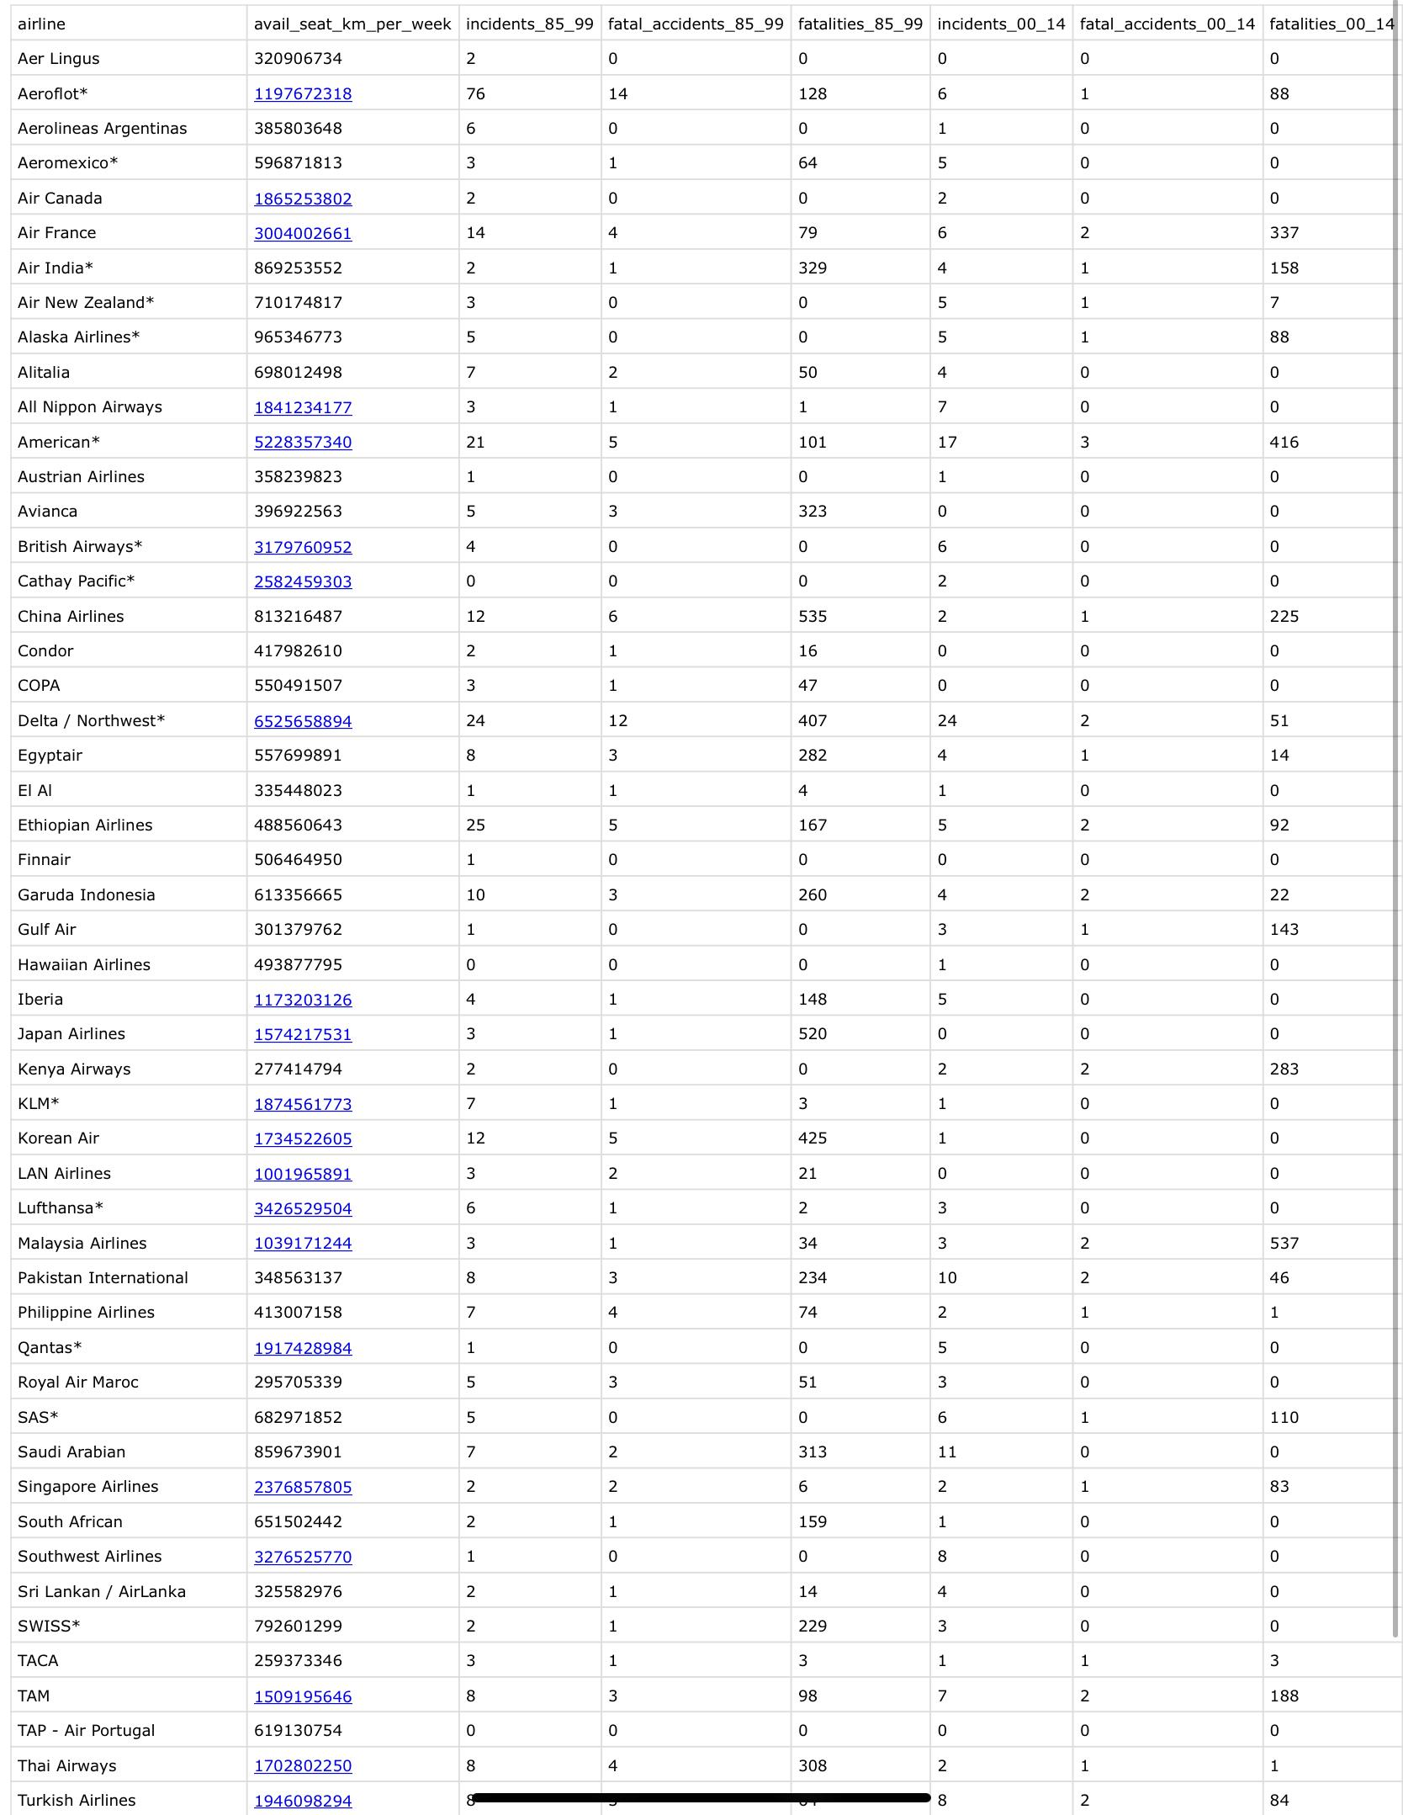

***Figure 2: Part of Data Header Output***

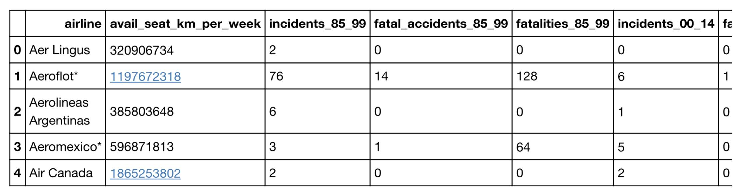

***Figure 3: Data Columns Output***

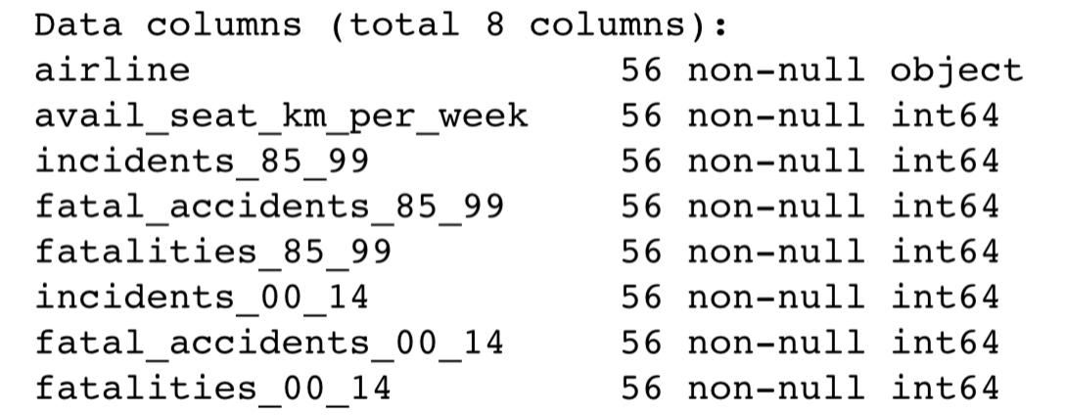

***Figure 4: Data Type Output***

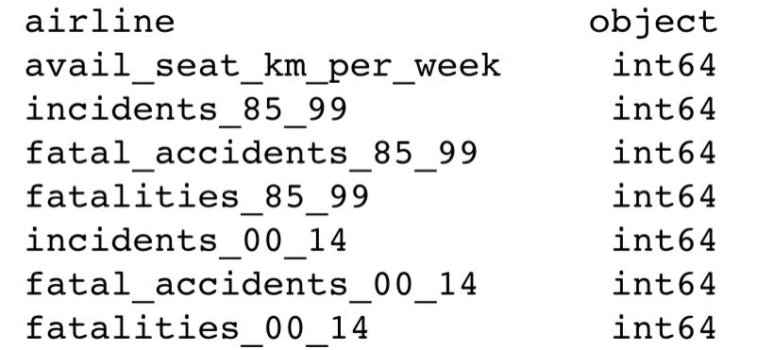

***Figure 5: Data Describe Output***

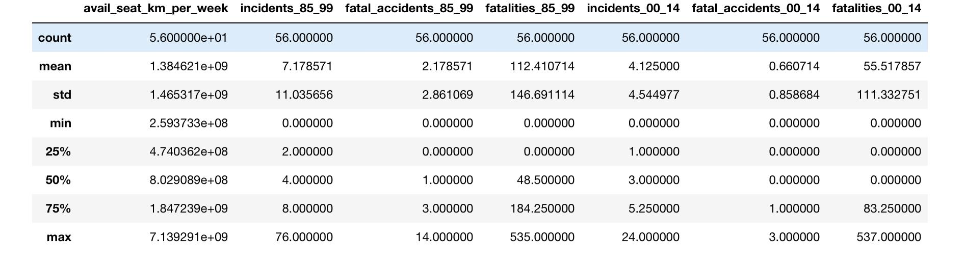

***Preliminary Data Discussion***

The output results show eight columns with 7 integer features and 1 categorical feature with a total of 56 airlines worldwide represented and 8 total features. The data set appears to be clean with no requirement for cleaning. There appear to be no missing values and unique values are displayed. It is duly noted that this is a smaller data set with less features, nonetheless valuable and important.